SPRINGBOARD
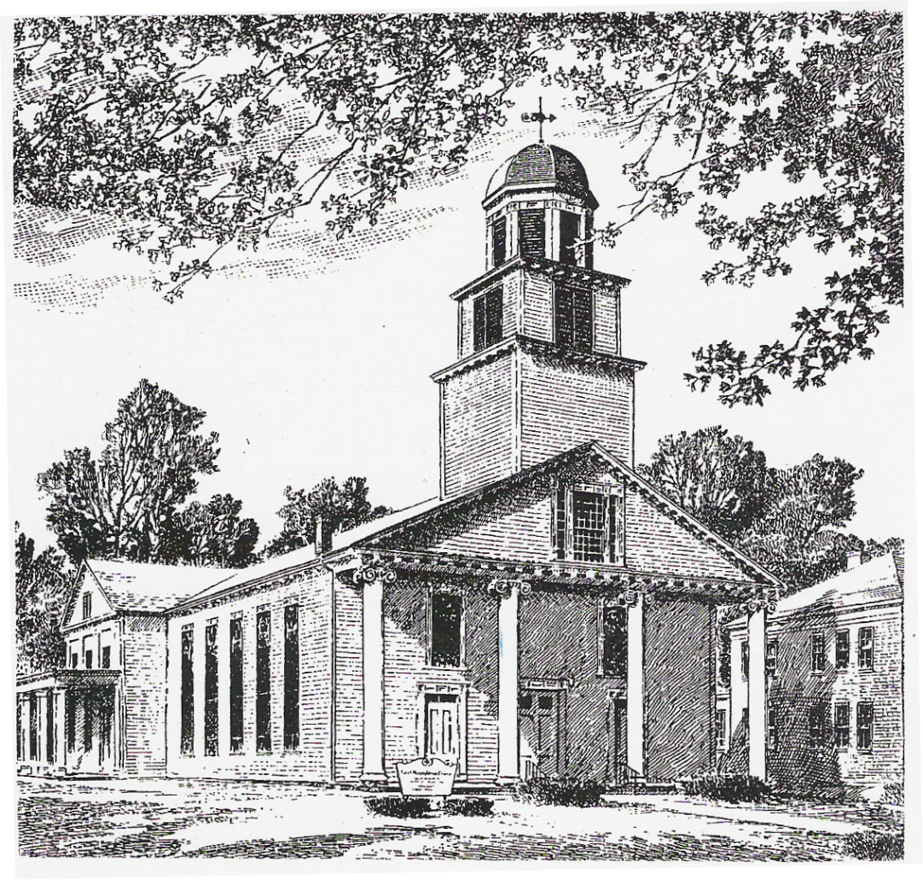

March 2024 – April 2024

News and Events of Interest for Members and Friends of the

First Presbyterian Church
Montgomery, NY

FOOD PANTRY
The Montgomery Food Pantry continues to serve our community’s increasing food insecurity as we have for more than 40 years.
As our Presbyterian faith encourages us to share our talents, I encourage you all to consider supporting this amazing and very needed mission. There are many ways to do that – through monetary or food donations, time spent working during Pantry hours or service as a coordinator or board member. The Pantry fulfills its mission as well as it does because of the incredible support of the people that staff it. Some of our clients even give back by volunteering! Currently, we pack non-perishable bags on Monday & Tuesday evenings from 6-7pm so that bags are ready to go for serving clients the next day. We distribute food on Tuesday mornings from 10am-12pm & Wednesday evenings from 6:30-8pm. Duties may include directing traffic (on Pantry property), taking orders, packing perishable items, toting bags, restocking items and taking out trash & recyclables. The Board of Directors (one to two people from each of the five member churches) meets quarterly to discuss how best to continue fulfilling our mission in the community.
First Presbyterian is in charge of volunteer help during the months of March, July and October; operations happen all year long, however, so anything you can do to help at any time is welcomed. If you have any questions, comments or concerns please call/text/email Robin McPhillips: 845-457-4194, 845-978-6457, rmcphil1120@gmail.com. THANK YOU!

WESTMINSTER GUILD
Saturday, March 9, 2024 @ 9am meeting will be followed by Brunch with Carrie Sweet Starr.
Guild Meeting Sunday April 14, 2024 after worship. Will be in combination with Prayer shawl.

PRAYER SHAWL
The prayer shawl group is having a joint meeting with the Westminster Guild on Sunday April 15th after church. If you would like to attend, we have members who can show you how to crochet, and you can pick the color shawl you would like to make!
If you would like to give a shawl, reach out to a member of the Deacons.

DEACONS’ SCHOLARSHIP
The Deacons’ are again offering a $200 Scholarship to a graduating High School senior! Each senior must complete a 500 word essay and submit it to a Deacon. For any other information or questions, please see any Deacon.

HOLY WEEK/EASTER SCHEDULE
Palm Sunday – March 24, 2024
Maundy Thursday Service – March 28, 2024 @ 7 p.m.
Good Friday Service – March 29, 2024 @ 7 p.m.
Easter Sunrise Service – March 31, 2024 @ 6:30 a.m. @ Riverside Park
Easter Worship Service – March 31, 2024 @ 11:30 a.m.

MARCH 2024

Mar. 3, Sun. 10:30 a.m. Sunday School
11:30 a.m. Worship – Sacrament of the Lord’s Supper
Home Communion
12:30 p.m. Board of Deacons Meeting
Mar. 7, Thurs. 7:00 p.m. Choir rehearsal
Mar.10, Sun. 10:30 a.m. Sunday School
Mar. 9, Sat. 9:00 a.m. Guild Meeting & brunch with Carrie Starr
11:30 a.m. Worship
Mar. 12, Tues. 7:00 p.m. Session Meeting
Mar. 14,Thurs. 7:00 p.m. Choir rehearsal
Mar. 17, Sun. 10:30 a.m. Sunday School
11:30 a.m. Worship
Mar. 21, Thurs. 7:00 p.m. Choir rehearsal
Mar. 24, Sun. Palm Sunday
10:30 a.m. Sunday School
11:30 a.m. Worship followed by Coffee & Conversation
Mar. 28, Thurs. 7:00 p.m. Maundy Thursday Service
Mar. 29, Fri. 7:00 p.m. Good Friday Service
Mar. 31, Sun. EASTER SUNDAY
Easter Sunrise Service @ Riverside Park
11:30 a.m. Easter Worship

BUILDINGS & GROUNDS
Painting, Painting, Painting. Nicer weather will help with the projects at the Church and the Manse. If you would like to help, feel free to reach out to John Nokland 845-234-6462

MENS FELLOWSHIP
Men's Fellowship will continue on Friday, March 15th @ 6pm at Vics Pizza in Montgomery.

HABITAT FOR HUMANITY
Goshen Presbyterian is having a fish fry take out dinner on Friday April 5th. All proceeds will benefit Presby Build committee Habitat of Newburgh. Adults $20 Children $10 5-7pm. You can call for tickets 845-294-7991.

**********************************************************************************
* SPECIAL DAYS *
* *
* Birthdays *
* Emily Adams – March 2 Marlene Wood – April 7 *
* Marcia Neubauer – March 3 Frank Pettine – April 10 *
* Ross Benedict – March 5 Casey Adams – April 12 *
* Laura Aiello – March 9 Cheryl Conero – April 15 *
* Henry Goldberg – March 13 Kimberly Neubauer – April 15 *
* Nikki Conero – March 14 Victoria Arnott – April 18 *
* Mary Prior – March 15 Allison Conero – April 24 *
* Marcus Mosenson – March 30 Heather Conley – April 29 *
* Emma Jardine – March 31 Donna Flannery – April 30 *
* *
**********************************************************************************

APRIL 2024

April 4, Thurs. 7:00 p.m. Choir rehearsal
April 7, Sun. 10:30 a.m. Sunday School
11:30 a.m. Worship– Sacrament of the Lord’s Supper
12:30 p.m. Deacons’ Meeting
April 11, Thurs. 7:00 p.m. Choir rehearsal
April 14, Sun. 10:30 a.m. Sunday School
11:30 a.m. Worship– followed by Westminster Guild
April 18, Thurs. 7:00 p.m. Choir rehearsal
April 21, Sun. 10:30 a.m. Sunday School
11:30 a.m. Worship
********DEADLINE FOR SPRINGBOARD ARTICLES ********
April 25 Thurs. 7:00 p.m. Choir rehearsal
April 28, Sun. 10:30 a.m. Sunday School
11:30 a.m. Worship

SUNDAY SCHOOL NEWS
Friday March 8th- Game night 5-8pm
Please come and enjoy a family friendly game night with our Sunday School Children. Feel free to bring a game, participate and have fun!!

UPDATED MEMBERSHIP LIST
A new membership list is available. As always if your address or telephone number has changed, please call the church office (457-5383) and leave a message with the correct information. Thanks!

CHANCEL FLOWERS
Anyone wishing to have flowers in church any time this year is asked to let our Floral Secretary know. Carolyn Henrie will be taking orders for chancel flowers, Easter lilies, and Mother’s & Father’s Day and poinsettia plants.
The cost of chancel flowers will be $10.00 and the others will be $13.00. Also, please let the Floral Secretary or the Church Secretary know of a birth of a child or grandchild in your family so this special occasion can be honored with a rose. This is a sponsored item and no cost to the family.
If you would like to have chancel flowers either as a memorial or special occasion, please print and fill out this from and give it to Carolyn, or you can leave it in the church office.

Checks should be made out to:
FIRST PRESBYTERIAN CHURCH FLOWER FUND
Your support of our church’s floral ministry is very much appreciated.
Carolyn

ORDER FORM FOR CHANCEL FLOWERS
The cost is $10.00.

Date you wish to sponsor flowers___________________________________

Donated by____________________________________________________

Wording (memory of/honor of)_____________________________________

_____________________________________________________________

Date you wish to sponsor flowers___________________________________

Donated by____________________________________________________

Wording_______________________________________________________

( ) I would like to sponsor and Easter lily ($13.00)
Wording_______________________________________________________

( ) I would like to sponsor a Mother’s Day plant ($13.00)
Wording_______________________________________________________

( ) I would like to sponsor a Father’s Day plant ($13.00)
Wording_______________________________________________________

( ) I would like to sponsor a Poinsettia ($13.00)
Wording_______________________________________________________

This is a list of church officers. Please refer to your membership list for telephone numbers.

Pastor –
Clerk of Session – Cynthia Nokland

SESSION (RULING Elders)
Class of 2024 Class of 2025 Class of 2026
Beth Hoeffner Carol Jellema Tom McNutt
Cynthia Nokland John Nokland Robin McPhillips
Beth Kehoe Beth Maida

BOARD OF DEACONS
Class of 2024 Class of 2025 Class of 2026
Kim Hoeffner Karla Ritter Debora Fagan
Diane Karsten Shawn Arnott Donna Powles
Joanne Toombs Emil Pignetti

SESSION COMMITTEE CHAIRPERSONS
Buildings & Grounds Committee John Nokland
Membership Development Committee Beth Kehoe
Nominating Committee Tom McNutt
Personnel Committee Robin McPhillips
Christian Education Committee Beth Maida
Stewardship & Budget Committee Cynthia Nokland
Worship Committee Carol Jellema
Mission Committee Beth Hoeffner

CHURCH STAFF
Office Secretary Carol Jellema
Church Treasurer Wendy McNutt
Financial Secretary Heather Benedict
Organist/Choir Director Marcia Woodall
Floral Secretary Carolyn Henrie
Custodians
Westminster Guild President Cynthia Nokland
Sunday School Officers
Chair of CE/Superintendent Beth Maida

The church office hours are Thursday from 9:00 a.m. to 1:00 p.m.
The office phone number is 845-457-5383 and our email is fpcmont137@frontiernet.net.
Visit our website at fpcmontgomery.com.

The church’s mailing address is: First Presbyterian Church
137 Clinton Street
Montgomery, NY 12549

